**PROJECT REPORT**

ROLE: FRONT END DEVELOPER (APSCHE-SMARTINTERNZ LONG TERM VIRTUAL INTERNSHIP)

PROJECT: WEATHER APP

COLLEGE: SRI VENKATESWARA DEGREE AND PG COLLEGE, ANANTAPUR

TEAM ID: LTVIP2023TMID02859

TEAM LEADER: Karanam Shriya Vaishnavi

TEAM MEMBERS: Kolimi AfiyaFirdos,

Kurra Sukesh,

Malasandram Ramanjineyulu,

K M Chandrakanth

INTRODUCTION

• Overview:

In Front end Development internship, we developed a weather app as the project with a team assigned by our mentor. We used html, CSS, javascript languages for it. Weather forecasting is the application of science and technology to predict the state of atmosphere for a given location. Weather is something that never remains constant. Getting to know precise weather conditions helps people to plan out their daily schedule. With weather forecasting technology reaching to the skies, dissemination of the forecast to has taken diverse routes. Weather app development is one such happy fallout.

Our Weather App enables the user to view the updated weather data for any given location. Some supplementary information is also presented within the app like prevailing humidity at the particular location and rain forecast.

• Purpose:

1. Provide the user with an easy and friendly interface.

2. Provide the user with the temperature of a particular region.

3. It will also show the weather and humidity.

LITERATURE SURVEY

• Existing problem:

During the development process, a literature survey was conducted to understand existing weather applications and their features. The existing weather applications are AccuWeather, NBC, etc.,. They’re either informative or provide facts and figures of temperature and air-pressure. One common problem with weather apps is the accuracy of the information provided. Sometimes, these apps rely on data from unreliable sources, leading to inaccurate weather forecasts and conditions. The limitations included intrusive ads and limited customization options.

• Proposed Solution:

Our Weather App enables the user to view the updated weather data for any given location. This weather app has features and new implementations as follows: i).Support multiple units, ii). Weather details of any region, iii). Simple design and user interface. Our App is totally based upon the OpenWeatherMap Server. The data is provided by the OpenWeatherMap to users by the means of API key. The API key is used to provide the security to cloud as only authorized user can access the weather information from the cloud and the details are accurate.

THEORITICAL ANALYSIS

• BLOCK DIAGRAMS:

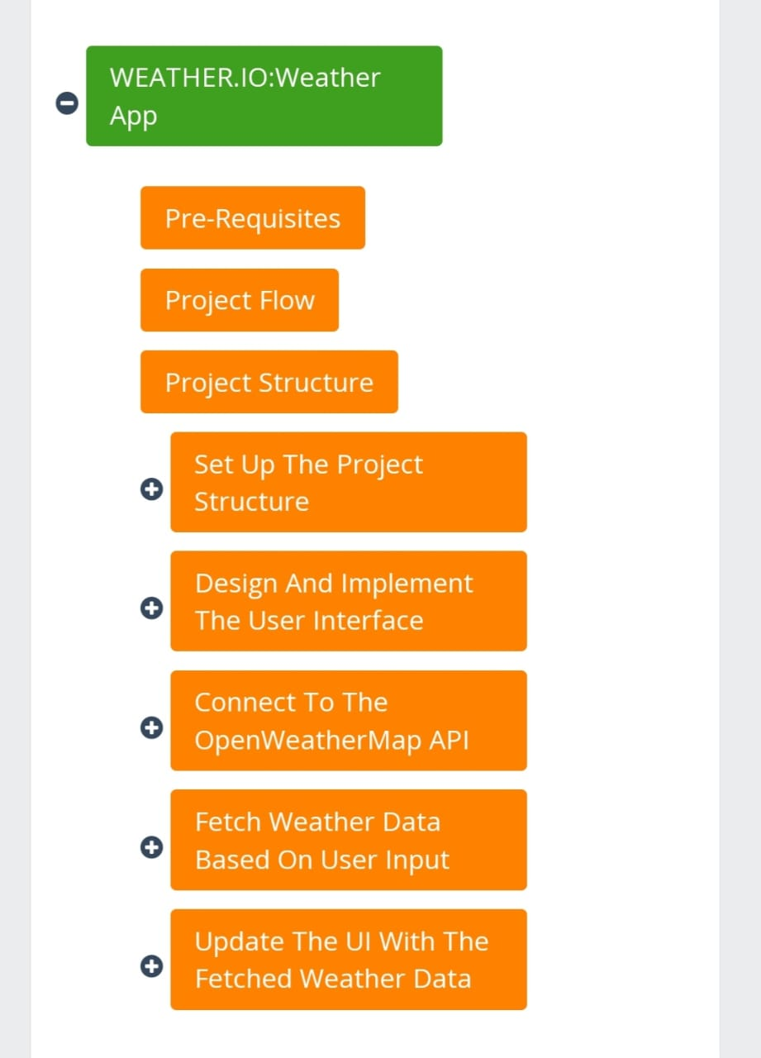

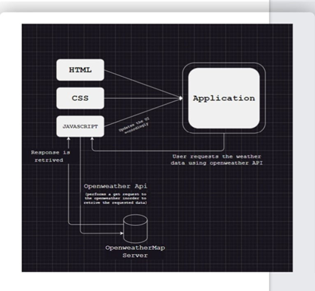

• Software/ Hardware:

1. Software requirements:

|  |  |
| --- | --- |
| Platform | Platform independent  (vs-code) |
| The Operating System | Windows10 |
| Framework | Bootstap |
| Front End Tool | Google Chrome |
| API | OpenWeatherMap |

2.Hardware requirements:

|  |  |
| --- | --- |
| Processor | Intel Pentium IV 2.9 GHz Other |
| RAM | Minimum 4GB |
| Graphics | Integrated Graphic Card |
| Hard Disk | Minimum 500 GB |

* Source Code:

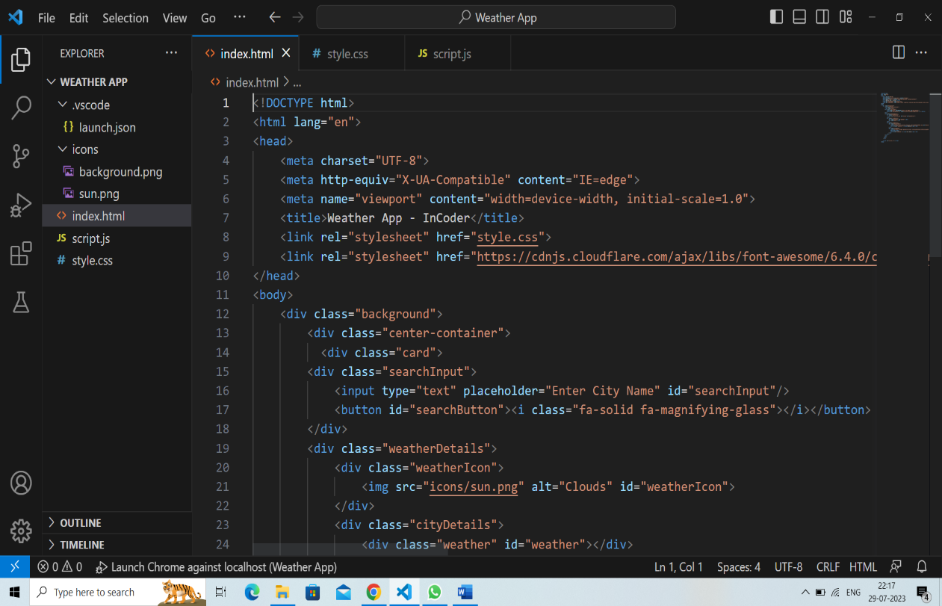

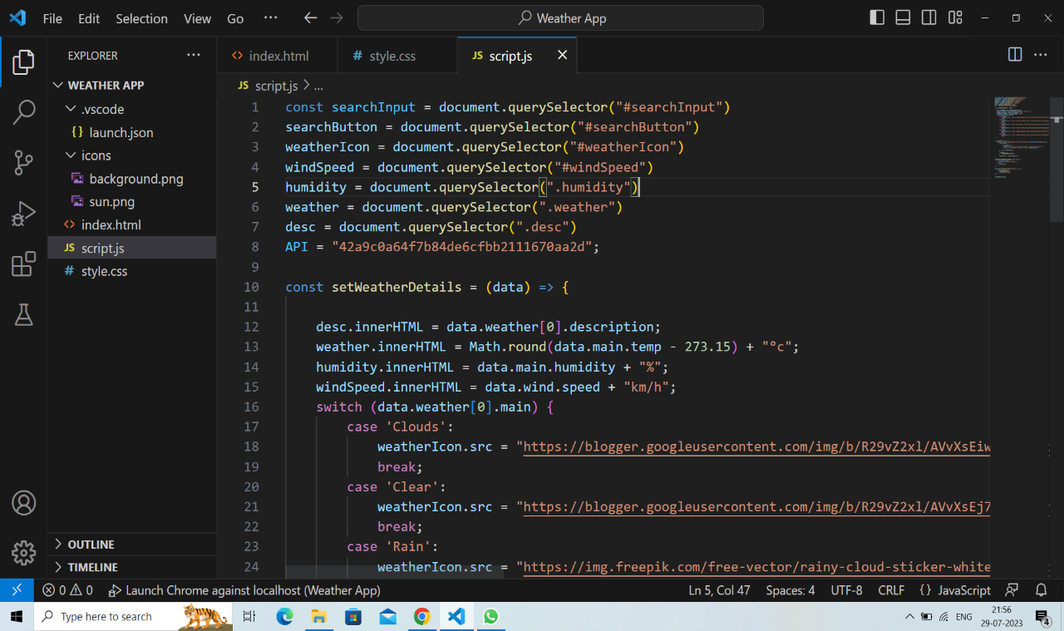RESULT

The Weather App successfully provides users with accurate and up-to-date weather information for their chosen location. The app's interface is intuitive and responsive, ensuring a seamless user experience. The weather data obtained from the API is displayed in a visually appealing manner, with weather icons representing different weather conditions. The images of output is as shown below:

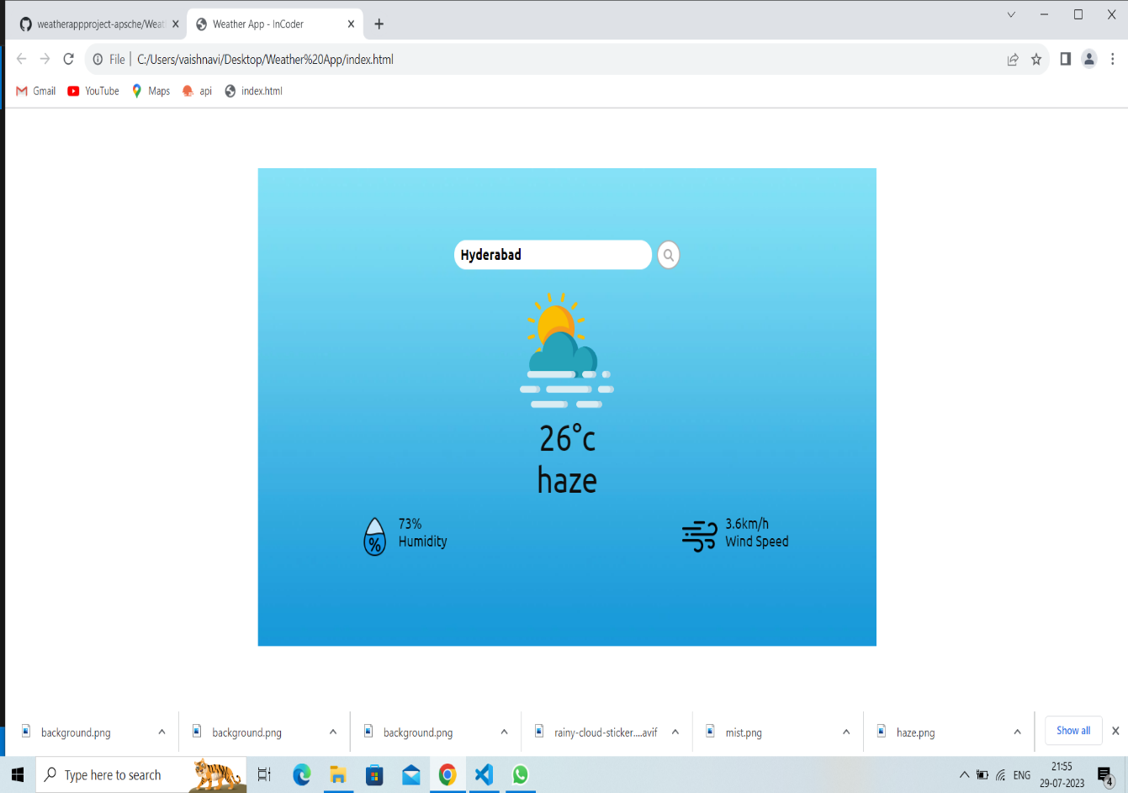

ADVANTAGES & DISADVANTAGES

• Advantages:

1. Real-Time Data is one of the biggest advantages of weather monitoring systems because of the ability to get the information in real-time.

2. Easy to use is definitely a big advantage of the weather monitoring system. It is so convenient and comfortable for users to get the most accurate information in the simplest way possible.

3. We can check the weather for the day when going out.

4. We can also check weather of other places when planning trips.

• Disadvantages:

1. It is difficult to predict weather when there is a poor network connection.

2. Limited Reach: Weather forecasts are not available for many remote or sparsely populated areas, making it difficult for people in these areas to prepare for severe weather.

3. Limited Time Frame: Forecasts are usually only accurate for a short time frame, making it difficult to plan ahead.

4. Although efforts are made accuracy is still aproblem.

APPLICATIONS

* Weather Reporting System is mostly used to monitor the continuously changing the climatic and weather conditions over controlled areas like houses, Industries, agriculture and etc.in real time monitoring.
* We can access the weather details very easily on mobile phones, laptops, etc., through weather app.
* We can use the app to check weather of our location when going somewhere.
* We can also use it for planning trips.
* Weather acts as a criteria for what clothes we should we should wear, what should we eat and drink, whether to carry an umbrella or boots and when to schedule our plans.

CONCLUSION

• We successfully created the weather app for the project with the help of our mentors and trainers in which it shows real-time weather details. It also shows the rainfall, temperature and humidity. We can search for any place and get its weather details. We used html, CSS and javascript languages to create it. We got the accurate weather details from OpenWeatherMap API and syn it to code. It is user friendly so that every user can handle it with ease. It is a simple application to use. This application is developed such that it will not use much RAM and memory space.

FUTURE SCOPE

We can make some enhancements to the app in the future.

• The user interface can be improved.

* Other details like Air-Quality, UV-Index, Sunrise and Sunset can be added.
* Predict hourly and weekly weather details.
* Customization: Provide users with options to customize the app including background images, color themes, font styles and widget support.